***INDEX***

Table of Contents

**Title of Innovation:** 2

**Founder** 2

**Introduction** 2

**Problem Statement** 3

**The Innovation thinking Behind ChatGPT** 3

**Risk And Challenges** 5

Figure 1 founder Name 2

Figure 2 Problem issues 3

Figure 3 picture 4

Figure 4 risk and challenges 5

Figure 5 Impact of AI 6

Figure 6 Conclusion 7

Figure 6 Conclusion 7

***Student Research Report on AI Assistants- ChatGPT***

# **Title of Innovation:**

An Intelligent Virtual Assistant for Personalized Productivity and Workflow Automation

# **Founder**

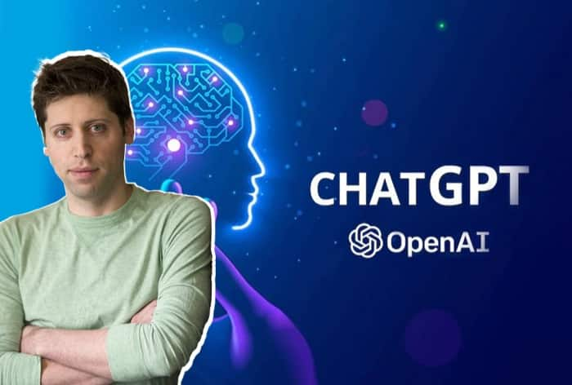

Figure founder Name

**Sam Altman**

# **Introduction**

This innovation project explores the development and deployment of **ChatGPT** as an advanced AI assistant tailored for professional, educational, and personal productivity. Leveraging natural language processing and machine learning, ChatGPT is designed to assist with knowledge generation, communication, task execution, and decision-making. The project will customize ChatGPT’s capabilities to suit user-specific workflows, integrate it with everyday platforms, and implement ethical AI practices for responsible use.

# **AI Problems Unveiled: Unavoidable Issues in AI Deployment Every Business FacesProblem Statement**

Figure Problem issues

Before AI Human faced many problems like:

* Despite rapid digitization
* individuals and organizations still struggle with information overload
* inefficient task management
* lack of access to real-time
* A smarter, more human-like assistant is needed—one that can support users across disciplines in a conversational and intuitive way.

# **The Innovation thinking Behind ChatGPT**

The innovation behind ChatGPT is rooted in several key concepts:

* leveraging **advanced language models** to automate and enhance tasks like brainstorming, content generation, coding, and problem-solving.
* By using **large-scale pretraining** and fine-tuning with human feedback, ChatGPT helps teams **boost productivity**, **accelerate decision-making**, and **streamline collaboration**.
* Its ability to **understand context** and **generate creative solutions** makes it a powerful tool for project planning, development, and execution.
* 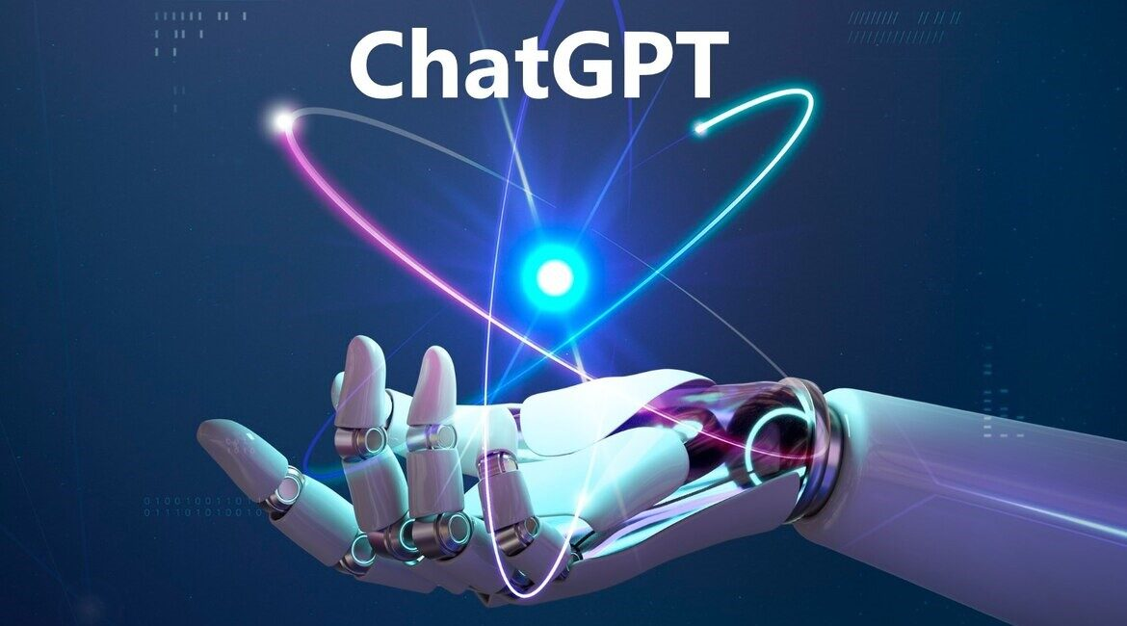The innovation focuses on **human-AI collaboration**, where ChatGPT acts as a supportive partner, improving efficiency and enabling more creative, data-driven outcomes.

**Core Features of ChatGPT as an AI Assistant**

Figure picture

* ✅ **Writing & Editing Help** – Drafts emails, reports, code snippets, lesson plans, or blog posts.
* ✅ **Task Automation** – Helps manage schedules, generate meeting notes, and create to-do lists.
* ✅ **Multilingual & Multimodal Communication** – Supports multiple languages, and in advanced models, visual inputs and audio.
* ✅ **Contextual Memory** *(optional with user consent)* – Remembers user preferences, styles, and recurring tasks.



Figure risk and challenges

# **Risk And Challenges**

These are key risks and challenges that the founders of ChatGPT had to manage while developing and launching the project.

**1. Technical Challenges**

* **Data Quality:** Ensuring clean, unbiased, and diverse datasets for training the AI.
* **Accuracy and Reliability:** Overcoming issues of the model generating incorrect or nonsensical answers.

**2. Ethical Challenges**

* **Misinformation Control:** Preventing the model from generating harmful or misleading content.
* **Privacy Concerns:** Safeguarding user data and ensuring compliance with privacy regulations.

**3. Financial & Resource Constraints**

* **High Costs:** Significant funding required for research, development, and infrastructure (cloud computing and hardware).
* **Talent Acquisition:** Attracting and retaining skilled AI researchers and engineers in a competitive market.

**7. Competitive Landscape**

* **AI Competition:** Competing with major tech companies and open-source projects in the AI space

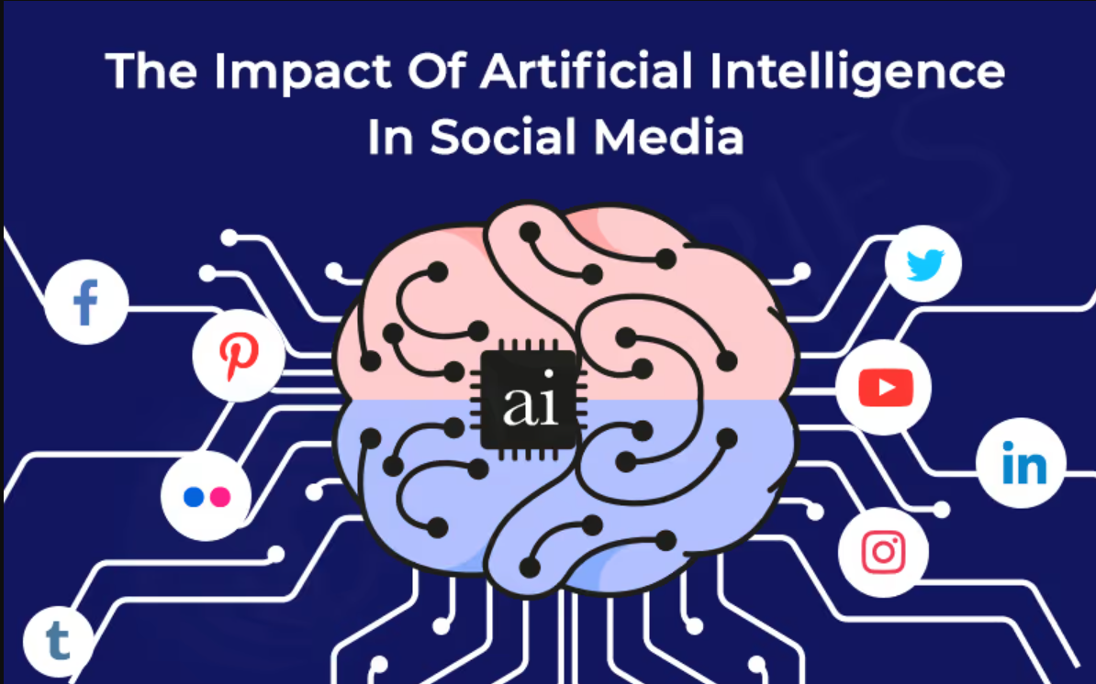 **Expected Impact**

Figure Impact of AI

* **Time Savings:** Reduce administrative workload by 30–50% for professionals.
* **Improved Productivity:** Enables users to focus on high-value tasks.
* **Accessibility:** Makes advanced productivity tools accessible to non-technical users.
* **Scalability:** Applicable in education, business, healthcare, and personal productivity.

**key Learnings**

* **Importance of Ethical AI:** Ensuring safety, fairness, and responsible use is critical.
* **User Feedback Matters:** Iterative improvement through real-world use was essential to refinement.
* **Data Quality is Crucial:** Better training data leads to more reliable and useful AI output.

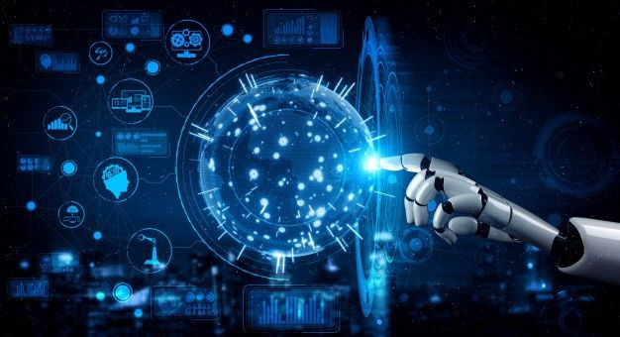 **Conclusion**

Figure Conclusion

Figure Conclusion

Intelli Mate is not just another virtual assistant—it is a smart productivity partner. By combining AI technologies with thoughtful design, this project aims to redefine how we interact with our digital workspace and manage our daily lives.

Founder or innovator name and picture?

Ans. Founder name is Sam Altman

real-World problem did they solve

Ans. The founders of ChatGPT—developed by OpenAI—set out to solve several real-world problems, primarily centered around making artificial intelligence more accessible, safe, and useful for people in everyday tasks.

**Here’s a breakdown of the core problems they aimed to address:**

🔍 1. Accessibility of Powerful AI Tools

🧠 2. Understanding and Generating Human Language

🛠 3. Improving Productivity and Efficiency

🧪 4. Safe Deployment of AI

🌐 5. Bridging the Gap Between Research and Applicatio